- Where in France are the Paleolithic caves?
The Paleolithic caves in France are in Lascaux.
- Why were the caves well preserved there?
The caves were preserved there because large amounts of archeological material was found.
- How was the entrance of the cave hidden?
The entrance of the cave was hidden in such a way that it was 110m from the valley bottom out of the total altitude of 185m.
- How old are the Caves of Lascaux?
The caves are 36,000 years old.
- Who discovered the paintings?
Andre Gory and Arlette Leroi-Gourhan discovered the paintings.
- How did they get in?
They got by enlarging the hole in the entrance with the help of three boys from the village. Upon entry into the hole, Marcel slid down to the bottom of the cave.
- What animals did they find show in the cave?
They found foxes in the cave.
- Why was the next passage difficult to pass?
The next passage was difficult to pass because
- What are the names of some of the chambers?
The other chambers are the Hall of the Bulls, the Axial Gallery, the Passageway, the Nave, the Chamber of the Felines, the Apse and the Shaft.
- How many people visited in one day?
4 people visited in one day. They included Henri Breuil, Jean Bouyssonie, Dr. Cheinier, Denis Peyrony.
- What was causing deterioration?
The deterioration was being caused rise in the CO2 levels from the large number of tourist who visited the place.
- How did they try to prevent deterioration?
They tried to prevent the deterioration by the installing an air regeneration system in the cave.
- When was it closed?
The cave was closed in 2017.
- Now is the cave returned to its state from the day of its discovery?
The cave has not been returned to its state from the day of recovery but conservation measures have been advanced by restriction of access to the hill.
- How can you see the cave today?
The cave can be seen by walking or by use of shuttle bus.
- When did Lascaux II open?
Lascaux II opened in 1983.

Cave 3d
1. Sea Lion Cave
Find 5 interesting facts about the Sea lion Caves.
The interesting facts about the sea lion caves are:
1. It is the largest cave in America



2. The cave hosts a variety of other animal species apart from the sea lions.
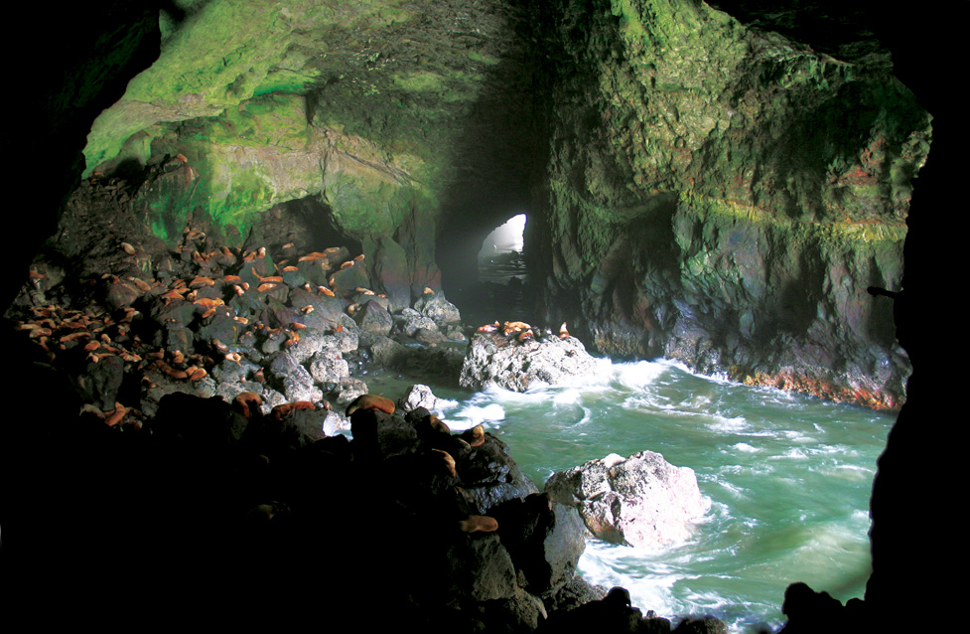

3. The height of the cave equals a 12-storey building.
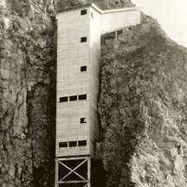
4. The northern entrance is elevated and can be used as a view point where all the wildlife can be seen from above. 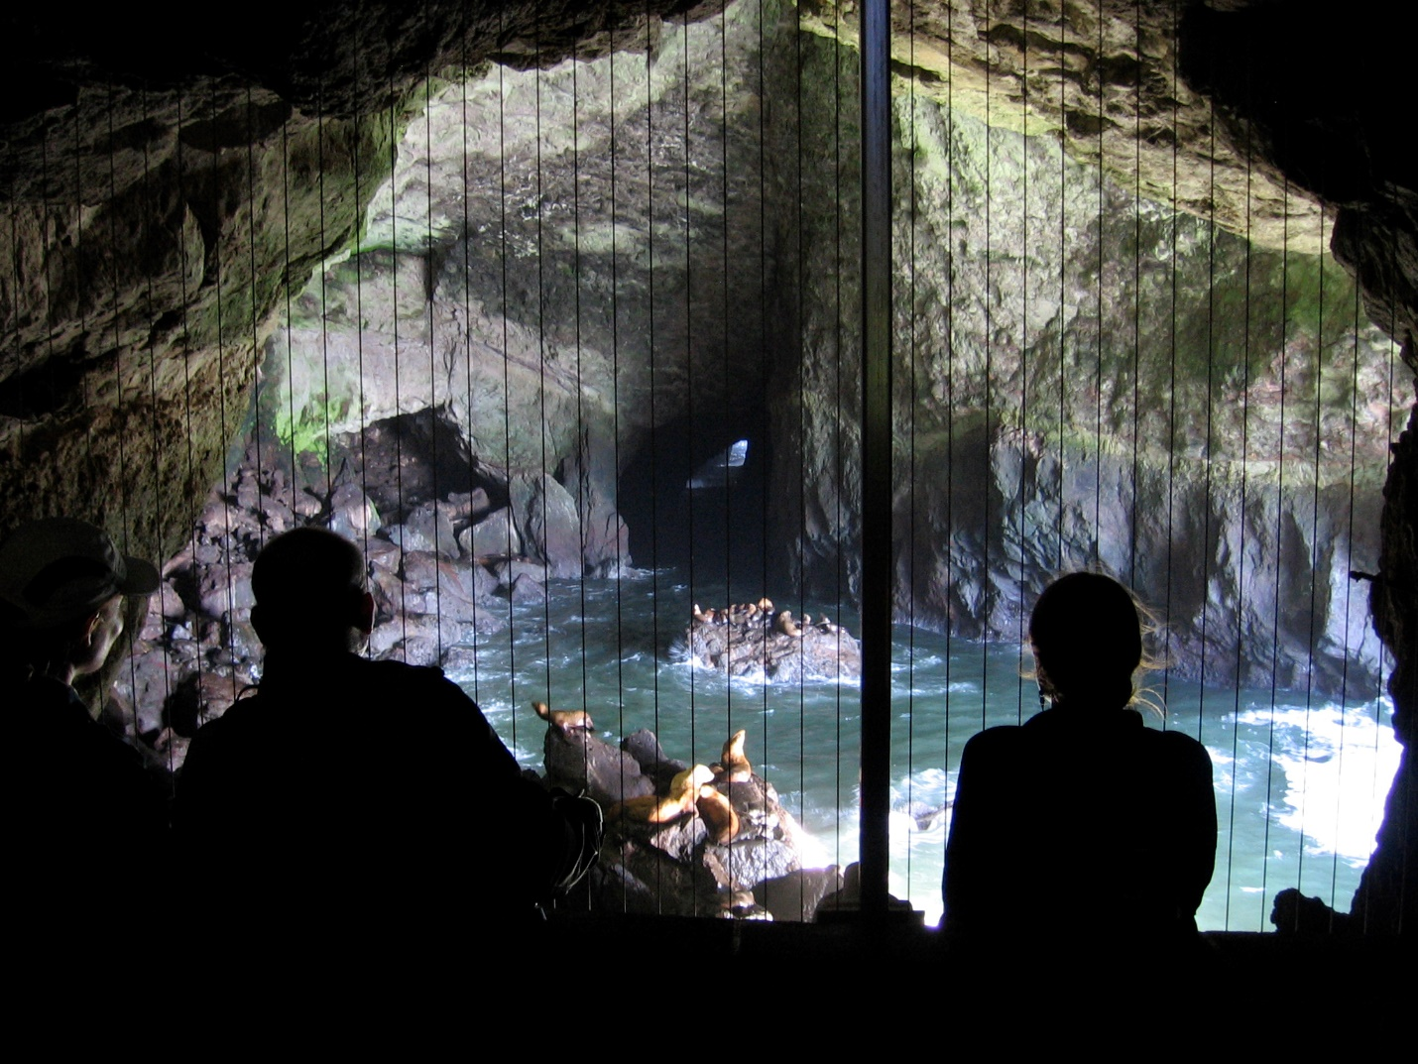

5. The cave has a 208 feet elevator.

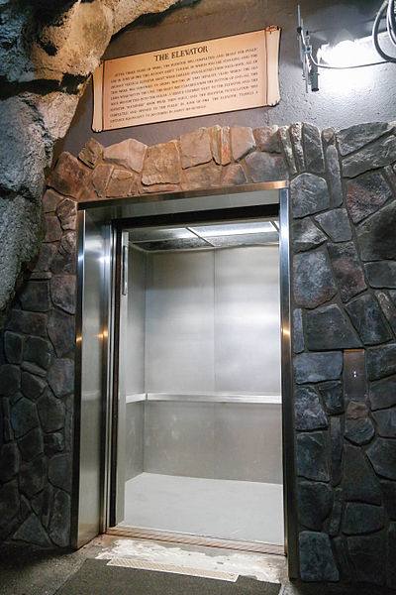

2. Solution caves
a. Where are most solution caves found?
Most solution caves are found in carbonate rocks such as limestone, dolomite and marble. It may also be found in gypsum. The cave’s occurrence in sandstones is due to the fact that carbonates stick them together. Apart from these, they also form in easily dissolving salts.
b. Write down what you selected in your tower and provide a description of what it is. Put a few pictures of what you selected in your tower. (Upload a snapshot so I can see it).
Splattermites
It is a unique kind of stalagmite with a platy appearance and it protrudes uprightly. The formation of splattermites occurs in tall caves where the drops from the ceiling hit the ground so fast and with splatter effect hence its name, splattermite. Rapid precipitation of calcites build up forming the feature, with the aid of cool dry air that gets in through the entrance. The air helps to evaporate calcite which deposits on the splatter plates. Splatter plates are mostly found in tropic soils with dense vegetation. High concentrations of carbon dioxide in the water is lost when the water seeps through to the cave and is exposed to the air in the cave.
The following pictures show the splattermites:
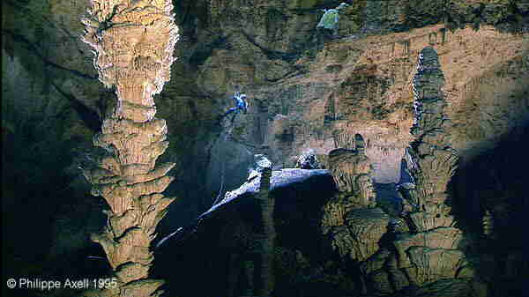


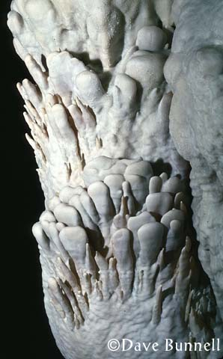

Cave Power Point Presentation
Create a power point presentation on one of the many famous caves around the world.
Presentation 2-Created

Child Development.
L11
The New-Born
1. What should you do with the crib comforter while your baby is under one year of age?
I should ensure that the crib comforter is not fluffy.
2. How many diapers can you plan on your baby using per week for the first 6 weeks?
70-90 diapers per week for the first six weeks are used.
3. How many diapers can you plan on your baby using per week after the first 6 weeks?
50 diapers per week after the first six weeks are used.
4. Why is alcohol essential for nursery and what is it used for?
Alcohol is essential for nursery and it is used to clean wounds.
5. About how many onesies or undershirts is suggested?
6 onesies or undershirts are suggested.
6. How many bottles are suggested?
12 bottles are suggested.
7. What is the farthest width the crib slats should be to prevent injury?
The crib slats should be 2 3/8 inches to prevent injury.
8. Why is it important that the headboard and footboard have no cutouts?
To prevent the baby’s head or limb from getting stuck.
9. List the surfaces in which to never sleep a baby on.
Unpadded raised surfaces should not be used to sleep the baby on.
10. Why is it important to never place a crib near blinds?
So as to prevent the baby from being chocked.
11. What is recommended to sleep your baby in?
It is recommended to sleep the baby in
12. What is recommended in a changing table?
A changing table should have a pad that the baby can lie on when being changed.
13. List 5 things to look for to ensure that the playpen you purchase is safe for playing and sleeping.
- It should meet up-to-date safety standards
- The distance between slats should not be more than 2 3/8 inches
- Purchase the one with both playpen, bassinet and changing table combined
- Choose the one with a comfortable back support mattress
- It should have no spaces lest the baby’s head or leg gets stuck.
14. Why should you ALWAYS buckle your child in a stroller or a shopping cart?
So as to avoid carrying the car seat.
15. List all 7 considerations when buying a car seat.
- Check if it meets the correct standards
- Ensure that the restraint you buy can fit into the vehicle
- Second-hand car seats are recommended
- Car seats more than 10 years should be avoided
- Consider car seats that can be retrained by a harness and not by a Velcro
- Instruction manual should be referred to when buying a second hand seat
- Check for wear, tear and breakages on the buckles and straps before using it

16. List the linens that are needed for a newborn
- Quilted mattress pads
- Crib sheets
- Waterproof mattress pads
17. What items are needed for a newborn “Medicine Cabinet?”
A newborn medicine cabinet needs a thermometer, pain reliever medicine, teething rings, gauze squares, hydrogen peroxide, wound cream, bandages, cool mist vaporizer, pedialyte/ricelyte and an infant sunscreen.
18. What clothing is recommended for a newborn?
Undershirts, infant gowns, sleepers/stretch suits, pairs of booties/socks, receiving blankets, a sweater and a hat are recommended for a newborn.
19. Name five of the miscellaneous items needed for a newborn:
Baby monitor, swing, baby book, infant seat, high chair, baby sling or pouch and a mobile.
20. When bathing your baby what will you need and what safety precautions can you take to ensure you baby stays safe?
A sponge-bath is required when bathing the baby. The baby should only be bathed upon the falling off of the umbilical cord and once the circumcision site has healed.
21. After the baby is at least 6 weeks old you may want to get out of the house with your baby, list what items you will need for your diaper bag?
- 5-6 diapers
- Disposable wipes
- Diaper rash cream
- Changing pad
- Plastic bags
- 2 sets of clothes for the baby
- Blanket
- Water bottles
- Powdered formula
- Burp cloth
- Pacifier
- Toy,
- Tylenol
- Sunscreen.
22. List the things in which parents can do to help prepare the other children in the home for the arrival of the new baby.
- Explaining the pregnancy status to the children
- Involving them in the care of the new baby

23. List the things in which parents can do to keep their baby safe if there are pets in their home and also make the pet comfortable with the new family addition
- Train the pet to get used to the new baby by pulling the ears or tail and rewarding it for well behaved instances.
- Let the pet get used to the scent of the baby before bringing the baby home.
- Avoid ignoring the pet when in the same room with the baby so as to feel regarded as part of the family.

L12
Preparing for Baby Part II
Presentation 3-Created

